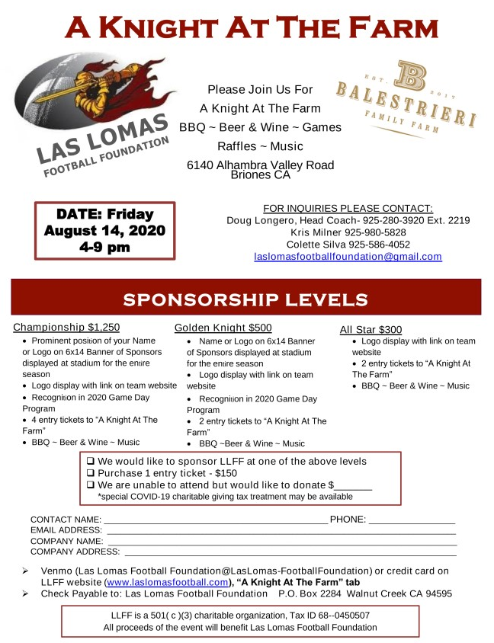https://docs.google.com/document/d/1WTX0M2RYKLJeinT9sMPH7mYu-v7j4zHvy363ruSAmtc/edit?usp=sharing

